# FLOWCHART DESIGN DIAGRAM FOR TASK 1

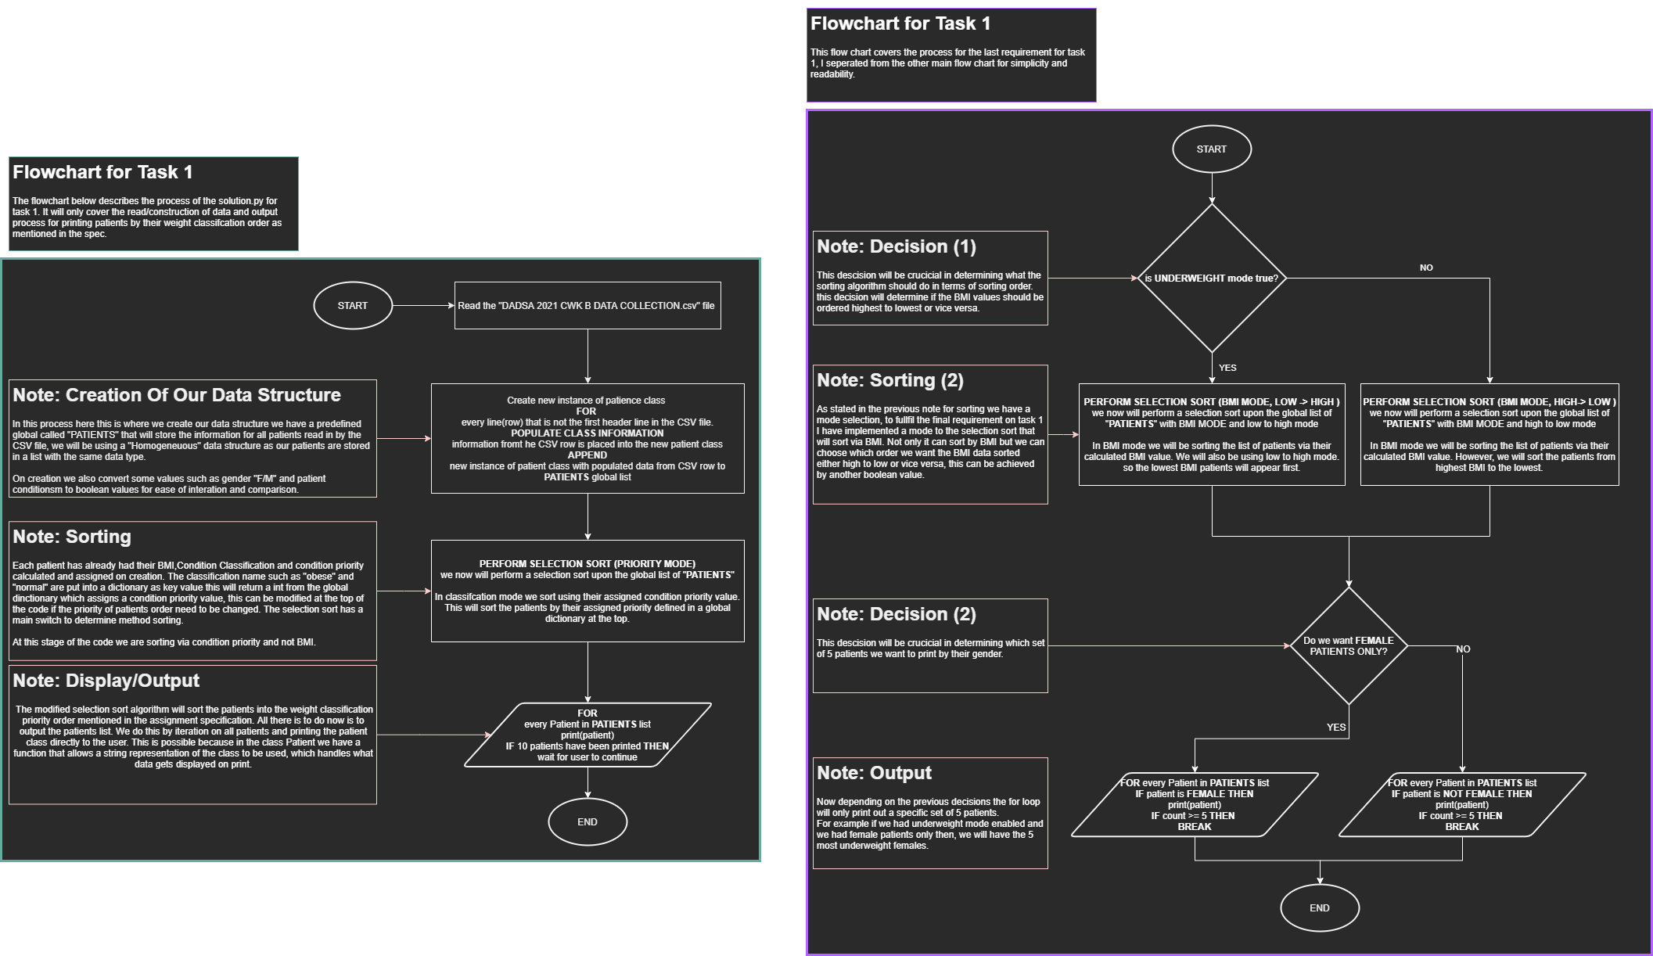

In the flowchart diagram above you can see my design for task 1. In this example I have described and outlined the processes of how my python script will handle and sort the patient information data and from the CSV file.

# PSEUDO CODE

## Read Datafile



In the provided text above you can see my pseudo code for task 1. In this example I am showing the read datafile method. This segment of code is responsible for reading the CSV file and converting it into a homogenous data structure. Each row of the CSV file will have its column values passed into a new instance of patient class and its data simplified to the use of Ternary operators: “Y” == True etc.

## Patient Class



In the provided text above you can see my pseudo code for task 1. In this example I am showing the patient class. This class is responsible for holding all data about our patient.

## Sorting Algorithm: Selection



In the provided text above you can see my pseudo code for task 1. In this example I am showing the sorting algorithm used to sort the patients. The sorting algorithm will sort the patients via lowest to highest by default unless the Boolean is given to sort it highest to lowest. There is also another Boolean that determines if we should sort via bmi values or their assigned given condition priority.

## Calculate Body Mass Index Function



In the provided text above you can see my pseudo code for task 1. In this example I am showing the calculate body mass index function. This function is responsible for calculating the BMI of a given patient object, the patient object will store their weight and height as a public variable. We access these variables to calculate the BMI with the given equation in the spec. the result is then assigned upon the patient object as a new value called BMI.

## Determine patient classification Function:



In the provided text above you can see my pseudo code for task 1. In this example I am showing the determine patient classification. This function is responsible for calculating and assigning a patient classification name. The patient object will have variables stored upon it that contain their body build and bmi. We access these variables to calculate the patient classification to the requirements of the spec. the classification name is then returned and assigned on the patient object.

## Calculate Age



In the provided text above you can see my pseudo code for task 1. In this example I am showing the calculate dob to age function. This function is responsible for calculating and assigning a patient age. The patient object will have a variable stored upon it that contain date of birth. We access this variable to calculate the patient age by finding the difference with date time now. The returned value is assigned and stored on the patient.